The Sustainability Score – SUMP benchmarking in the Netherlands

Contribution to the ENDURANCE e-update on Monitoring and Evaluation
DTV Consultants
February 2016

The “Sustainability Score” is a tool that is used for assessment and benchmarking of mobility in municipalities in the Netherlands. It was developed in 2014 by CROW (former KpVV, link in Dutch), an independent Dutch knowledge platform for infrastructure, public space, traffic and transport.
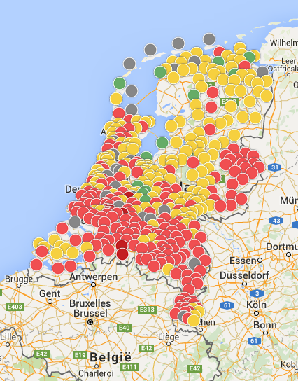
The “Sustainability Score” allows cities and provinces to quickly get an overview of how sustainable their traffic situation is. It also gives a first impression of the integration (or lack thereof) of sustainable mobility in the municipal policies. It therefore is a good starting point for a dialogue on how to make the mobility situation in a city more sustainable and it helps to generate ideas for new policies. The “Sustainability Score” allows cities to compare their mobility policies to those of others and it shows strengths and areas for improvement. It can also help in communicating about sustainability towards colleagues, citizens and politicians.

The “Sustainability Score” is calculated by CROW and based on ten indicators (see next page). Each one is related to a variable that allows comparison between municipalities, for example by dividing by the number of inhabitants, vehicles or houses. Five indicators are related to achieving sustainable targets: climate, air, traffic safety, noise and accessibility. These are important for our wellbeing, welfare and planet and say something about the effects and outcome of the mobility situation. The other five relate to sustainable elements of the mobility system: number of shared cars, loading poles for electric vehicles, Park&Ride and carpool areas, clean buses and modal split.

---
More information, a ranking of Dutch “sustainable cities“ and the exact sources that were used for each indicator can be found on www.duurzaamheidsscore.nl – in Dutch only. Questions in English can be directed to r.martijnse@dtvconsultants.nl

(See next page)
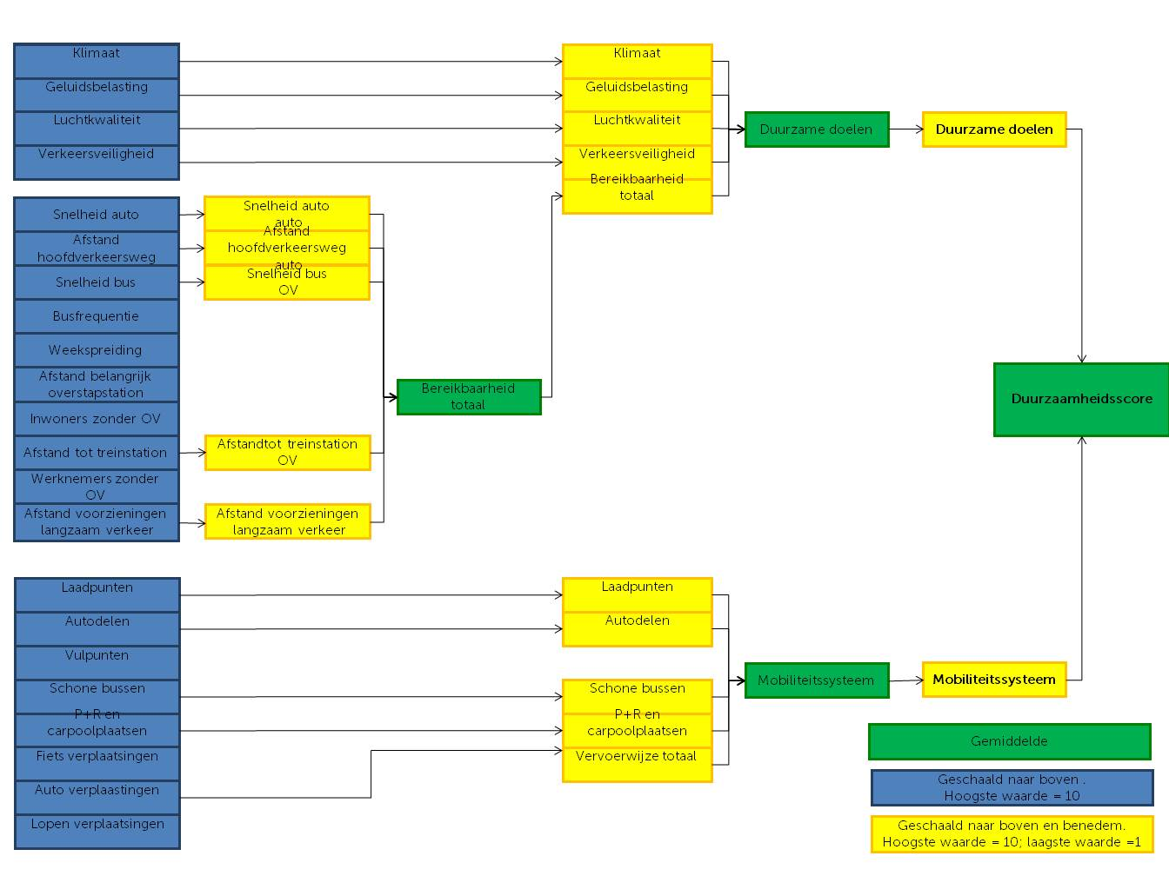
Climate
Noise
Road safety
Air quality
Car speed
Distance main traffic road
Bus speed
Week distribution
Bus frequency
Distance major interchange
Citizens without PT
Distance to railway station
Employees without PT
Distance slow traffic provisions
Charging points
Car sharing
Filling stations
Clean buses
P+R, carpoolspots
Bike trips
Car trips
Walking trips
Scaled up, highest value = 10
Distance to railway station
Charging points
Distance slow traffic provisions
Car speed
Distance main traffic road
Bus speed
Clean buses
Car sharing
P+R, carpoolspots
Mode total
Accessibility total
Road safety
Air quality
Noise
Climate
Sustainable targets
Mobility system
Scaled up and down,
highest value = 10; lowest value = 1
Accessibility total
Sustainable targets
Mobility system
Average
Sustainability score

