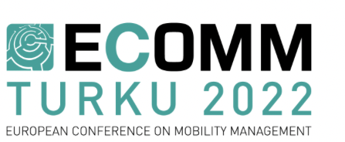

Dear applicant!

This year ECOMM also facilitates a number of 1,5-hour invited sessions, formatted as discussion panels, standard sessions, workshops or other special interactive sessions on a particular subject closely related to the ECOMM 2022 topics.

The invited session is organized by its host, who will be responsible for calling and looking for presenters. Each invited session should include 4-5 presentations with different speakers, coming from at least three different institutions or countries and not representing only one project. The applicant of an invited session is assumed to organize and chair it and signs fully responsible for a high-quality session.

A proposal should include a title, the session outline and full description, the names of the proposed chairperson and speakers (their affiliations and titles of the presentations / talks) and a short justification, why this session should take place at ECOMM 2022.

If you are interested in an invited session, please fill in this form and and send it to The EPOMM coordinator Ingrid Briesner until Wednesday, 3rd of December 2021, 23:59 CET.

- Title of the Session (max. 12 words):

- Session outline (ca. 100 words; this is used also for the Conference Programme):

- Session full description (aims, scope, outcome; ca. 300 words; this is used for the evaluation):

- The main topics of the Conference that this Session will address, please mark 1 or 2 (please also see Call for Presentations 2022):
Topic 1 - Modal Share Growth of Public Transport
Topic 2 - Mobility Management & Economic Instruments
Topic 3 - The New Use of Urban Space
Topic 4 - Life as a Service: Connecting People and Services
Topic 5 - The Use of Data in Mobility Management

- Session organisers (persons and their affiliations):

- Proposed Speakers (persons, their affiliations and titles of the presentations / talks):

- Session moderators (persons and their affiliations):

- A statement of justification – why is this session relevant in the ECOMM 2022?

